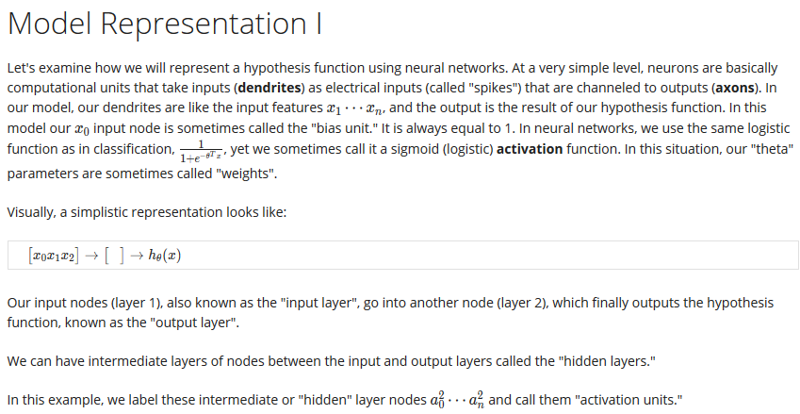

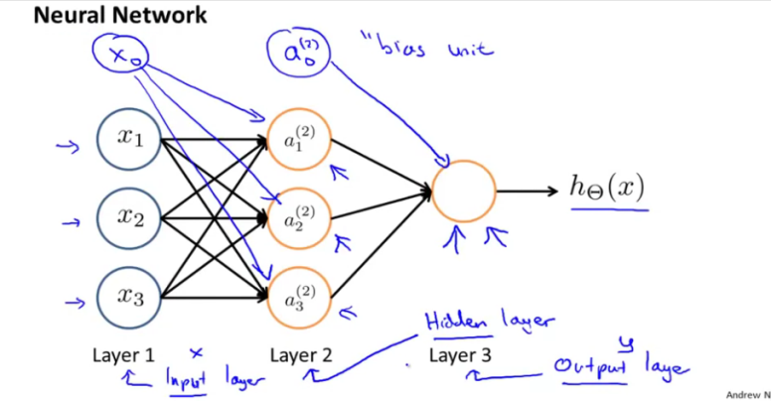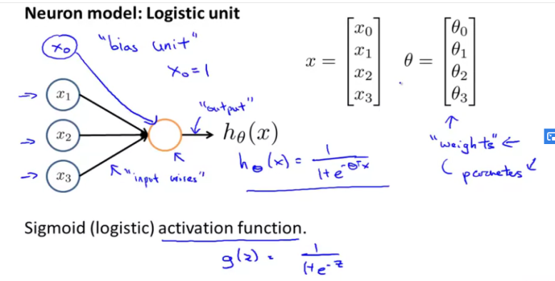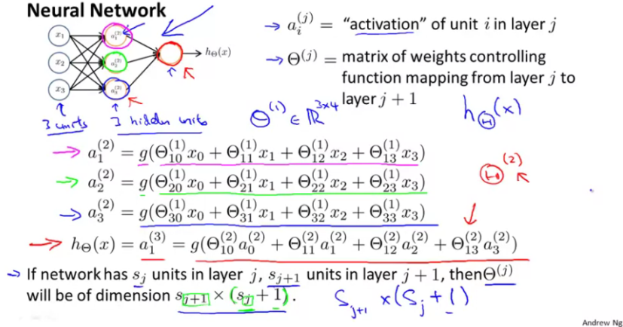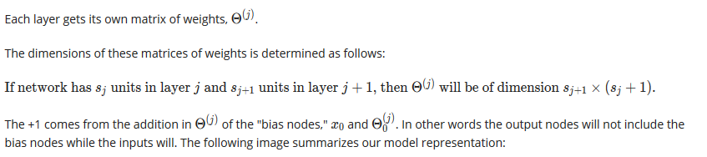

X0 – bias unit for a2 hidden layer

A^(2) 0- Bias unit for output layer

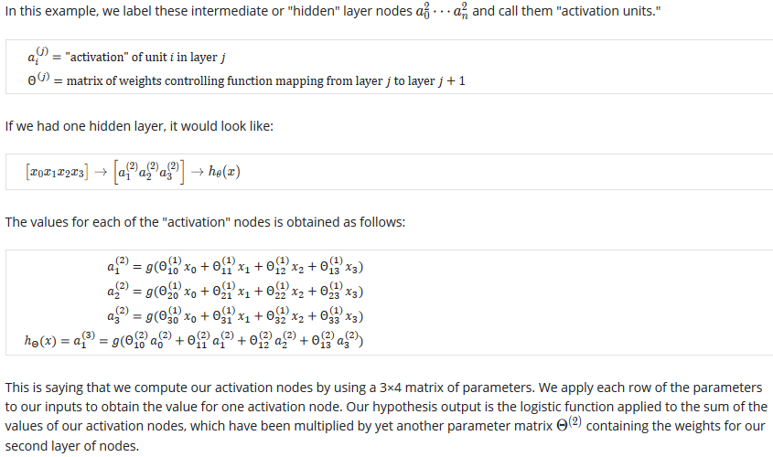

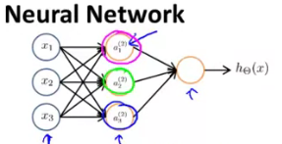

This will have 3 * 4 matrixi.e without x0 and theta0

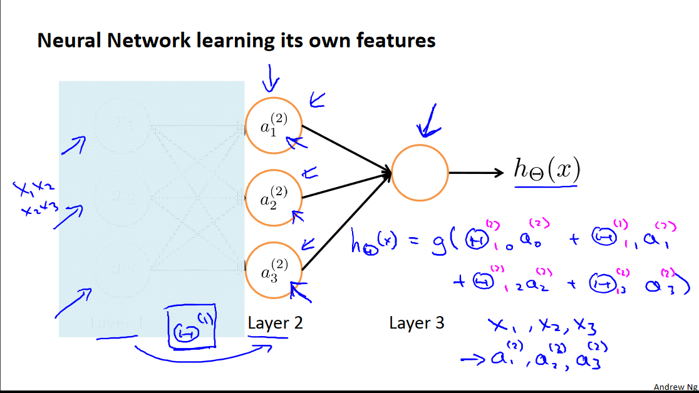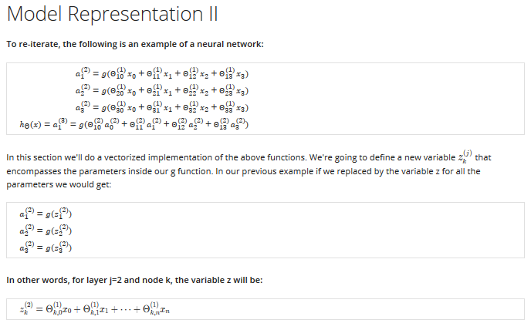

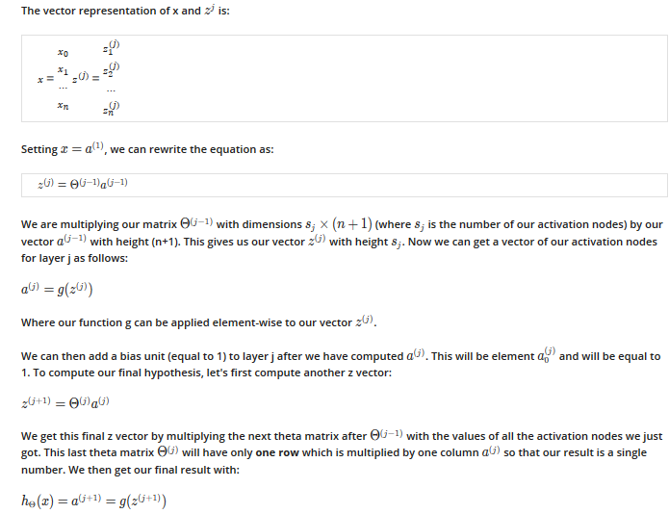

Z^2= θ^1 * a^1



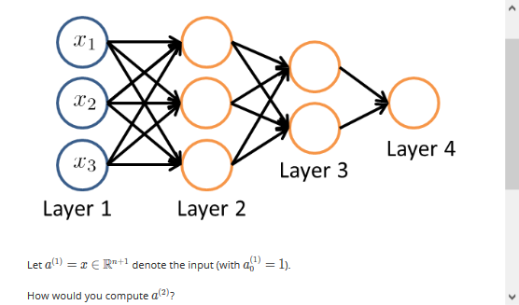

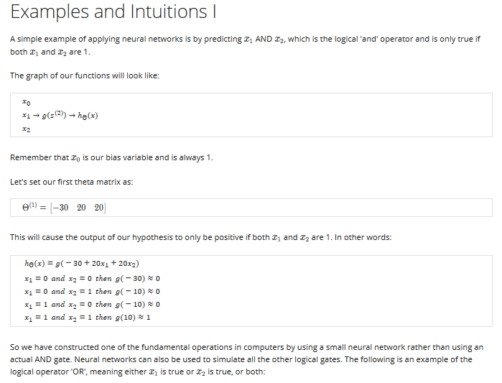

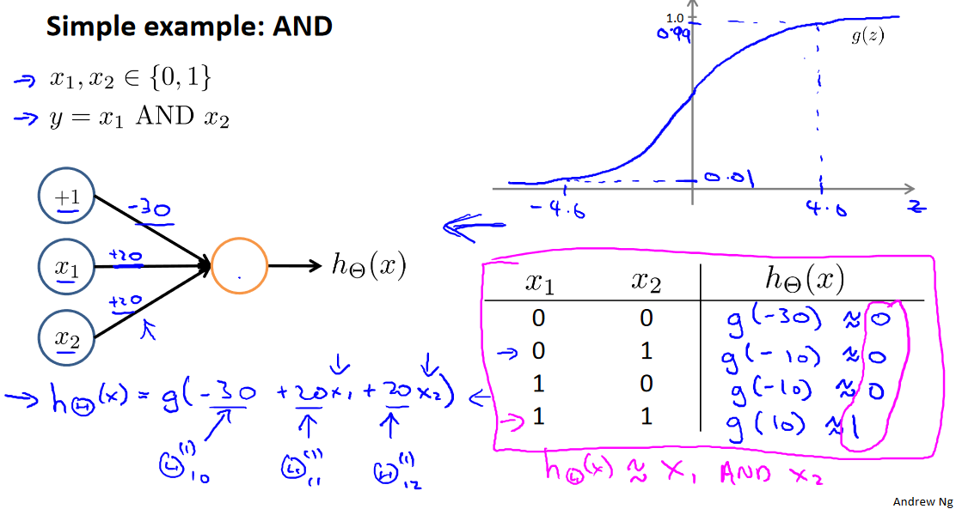

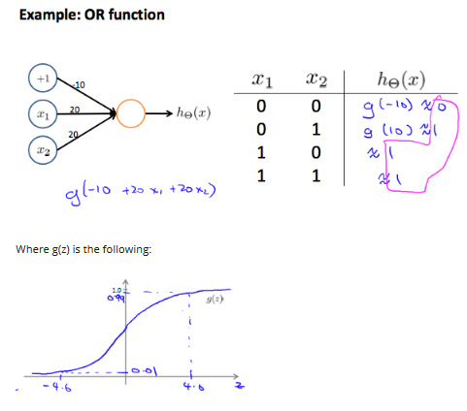

X1 or X2

***XOR****,* which stands for *Exclusive OR,* and ***XNOR****,* which stands for *Exclusive NOR.*

**XOR**, the output is HIGH if one, and only one, of the inputs is HIGH. If both inputs are LOW or both are LOW, the output is LOW.

Or and XOR are different.

***XNOR*** *gate* is an XOR gate whose output is inverted.

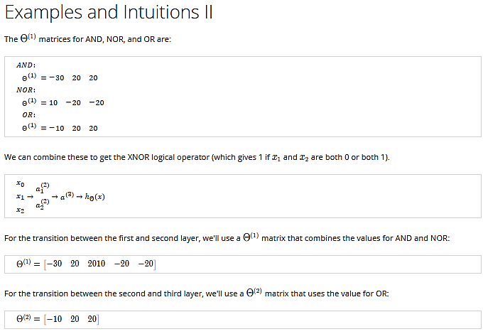

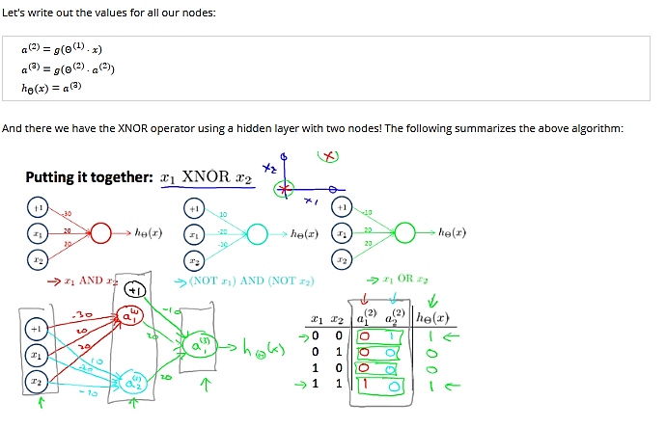

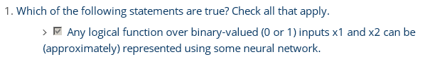

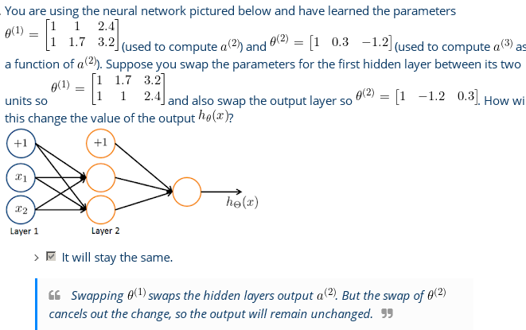

2.

Weeek 4---End(week 5 below)

**Week-5:**

**Deriving a Cost Function:**

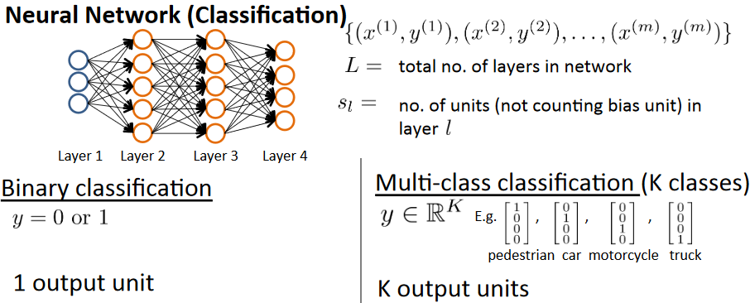

S1=3,S2=5,S3=5,S4=4

4 Units